PIZZA SALES SQL QUERIES – DATA ANALYST PROJECT
- Total Revenue
select sum(total_price) as Total_Revenue from pizza_sales;
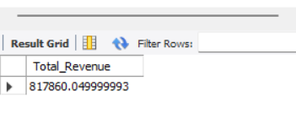
- Total Average
select sum(total_price) / count(distinct order_id) as Avg_Order_Value from pizza_sales;
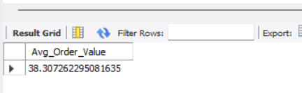
- Total Pizza’s Sold
select sum(quantity) as Total_Pizza_Sold from pizza_sales;
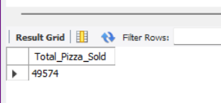
- Total Orders
select count(distinct order_id) as Total_Orders from pizza_sales;
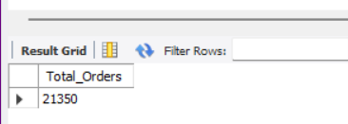
- Average Pizzas Per Order
select cast(sum(quantity) / count(distinct order_id) as decimal(10,2)) as Avg_Pizzas_Per_Order from pizza_sales;
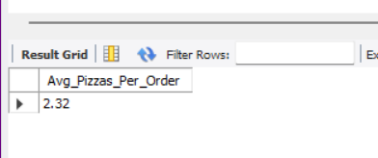
- Total Orders During a Specific Month
SELECT
MONTHNAME(order_date_converted) AS Month_Name,
COUNT(DISTINCT order_id) AS Total_Orders
FROM
pizza_sales
GROUP BY
MONTH(order_date_converted), MONTHNAME(order_date_converted)
ORDER BY
MONTH(order_date_converted) desc;
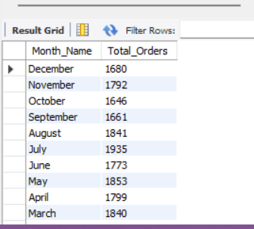
- Percentage of Total Sales
select pizza_category, sum(total_price)*100/(select sum(total_price) from pizza_sales) as PCT
from pizza_sales
group by pizza_category;
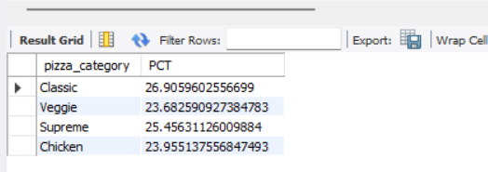
Note:
For every month we use
SELECT
pizza_category,
SUM(total_price) AS Total_Sales,
SUM(total_price) * 100.0 / (SELECT SUM(total_price) FROM pizza_sales WHERE MONTH(order_date_converted) = 1) AS PCT
FROM pizza_sales
WHERE MONTH(order_date_converted) = 1
GROUP BY pizza_category;
- Percentage of Sales by Pizza Size
SELECT
pizza_size,
SUM(total_price) AS Total_Sales,
SUM(total_price) * 100.0 / (SELECT SUM(total_price) FROM pizza_sales) AS PCT
FROM pizza_sales
GROUP BY pizza_size
order by PCT desc;
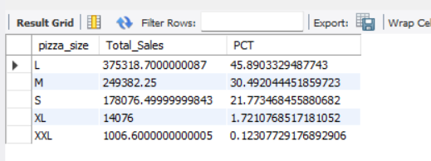
- Top 5 Best Sellers by Revenue
select pizza_name, sum(total_price) as Total_Revenue from pizza_sales
group by pizza_name
order by Total_Revenue desc limit 5;
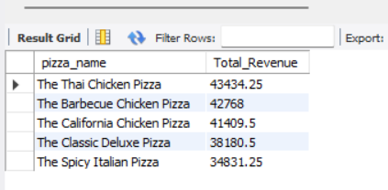
- Top 5 Best Sellers by Quantity
select pizza_name, sum(quantity) as Total_Quantity from pizza_sales
group by pizza_name
order by Total_Quantity desc limit 5;
